Monroe Playground Foundation
DRAWING
Wolfe’s Den – Wolfe Park
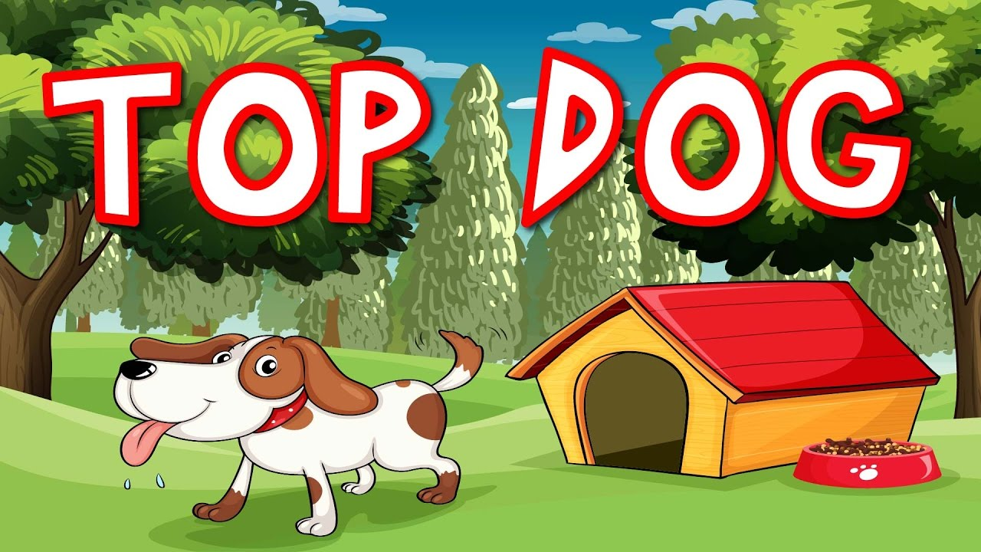
JUNE is dog licensing month
For the entire month we are raising money for the Monroe Playground Foundation
Enter into a drawing ($5.00) to win the
TOP DOG TAG #1, #2 or #3!
$5.00 will go directly towards
the new playground
Winners will be photographed and announced!
If you are mailing in your renewal and are interested in participating – please make a separate $5.00 check out to “The Town of Monroe, CT”
For further information call: 203-452-2811 or email dog@monroect.org

